Assignment 2

Topic: Supervised and Regression

Name: Bradley Yaman

NIM: 20230040287

­­­­­­­­­­­

* Question : we have data on average income and total pizza sales for 1 month in eight cities:

|  |  |  |
| --- | --- | --- |
| **City** | **Average Income(1000$)** | **Pizza Sell(1000 pcs)** |
| 1 | 5 | 27 |
| 2 | 10 | 46 |
| 3 | 20 | 73 |
| 4 | 8 | 40 |
| 5 | 4 | 30 |
| 6 | 6 | 28 |
| 7 | 12 | 46 |
| 8 | 15 | 59 |

1. Make Scatter diagram

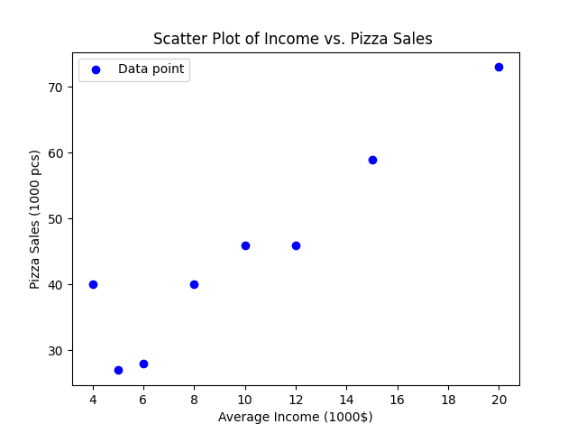

1. Are the two variables correlated?

* Indeed, my correlation coefficient, R = 0.984, shows a significant positive relationship between average income and pizza sales. Since it is 1, it also shows a positive relationship between average income and pizza sales.

1. Count:
2. Slope



1. Intercept



1. SSR, SSE, SST, R

